If you purchased our Raspberry Pi G1 Tank, you need to perform the following steps:

Step 1: After the G1 Tank is assembled, you will need to download the Raspberry Pi image we provided.

# Please click “Download ZIP” on Raspberry pi G1 Tank repository to download the image.

Link: <https://www.yahboom.net/study/G1-T-PI>

Step 2: You need to burn the image to the Raspberry Pi SD card.

For the method of burning the image, please click the location as shown in the figure below, and read the contents carefully.

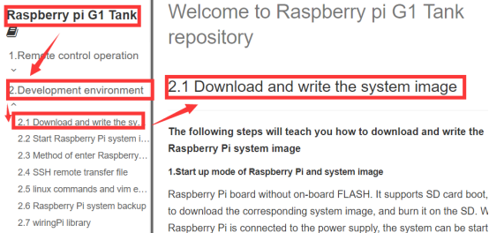

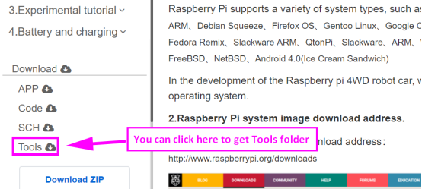

Step 3: After the burning is completed, you need to insert the SD card into the card slot behind the Raspberry Pi, as shown in the figure below.

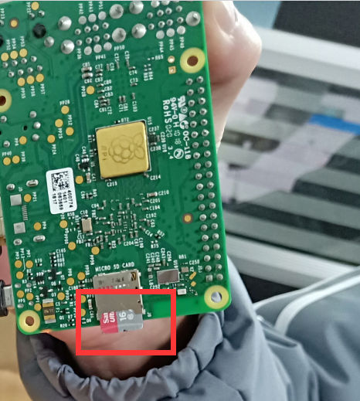

Step 4: You need to connect the Raspberry Pi board to the 4WD expansion board by the 40PIN cable, as shown in the figure below.

 (Please ensure the correctness of the connection)

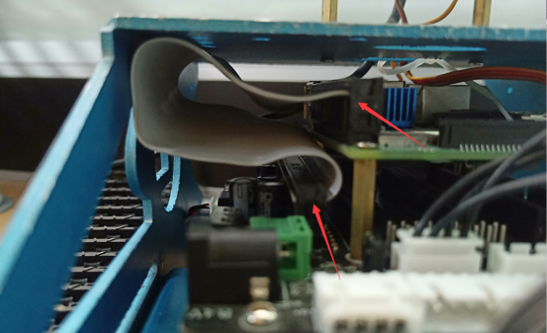

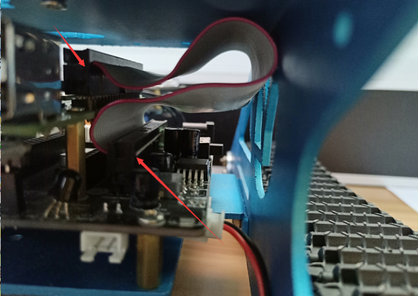

Step 5: Android users scan the following QR code by browser or search "YahboomRobot" in Play Store to download APP;

iOS users scan the following QR code by camera or search "YahboomRobot" in App Store to download APP.

!!Note:Because the software is relatively large, the download takes a certain amount of time, please be patient.



**Note:During installation, If you find any prompts on your phone (for example: location permissions of your phone). You must select "Allow".**

Step 6:After the APP is installed, open the Bluetooth of the your phone, open the power switch of the Tank, the red indicator of the Bluetooth module keeps flashing.

Step7:Then, open the **YahboomRobot** APK. You will see the APK interface and we need to click on the top left corner of the APK to select the device as shown below.

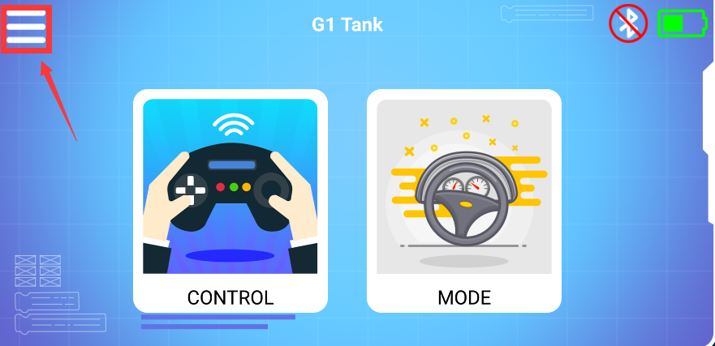

Step 8: Select 【G1 Tank】to enter the remote control interface, as shown below:

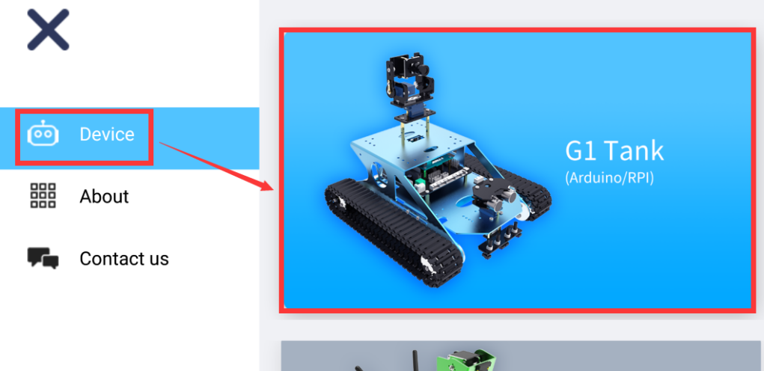

Step 9: You will this interface as shown below. Click on the top right corner of the APK to connect bluetooth.

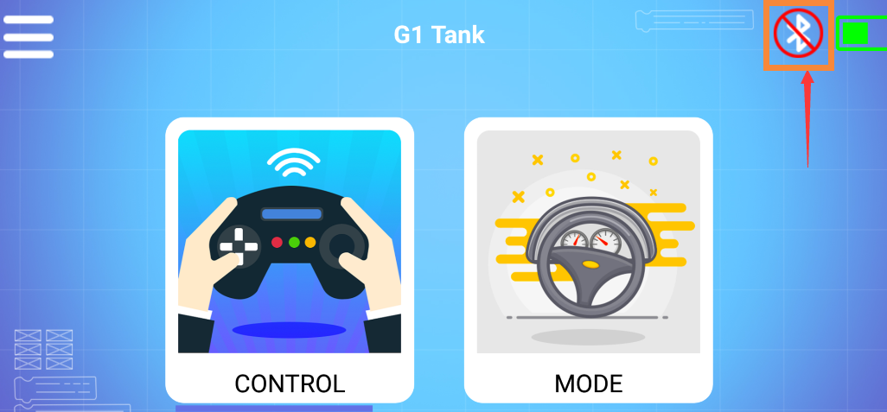

Step 10: You can see bluetooth signal. Wait patiently, the phone will automatically connect to the Bluetooth near the Tank.

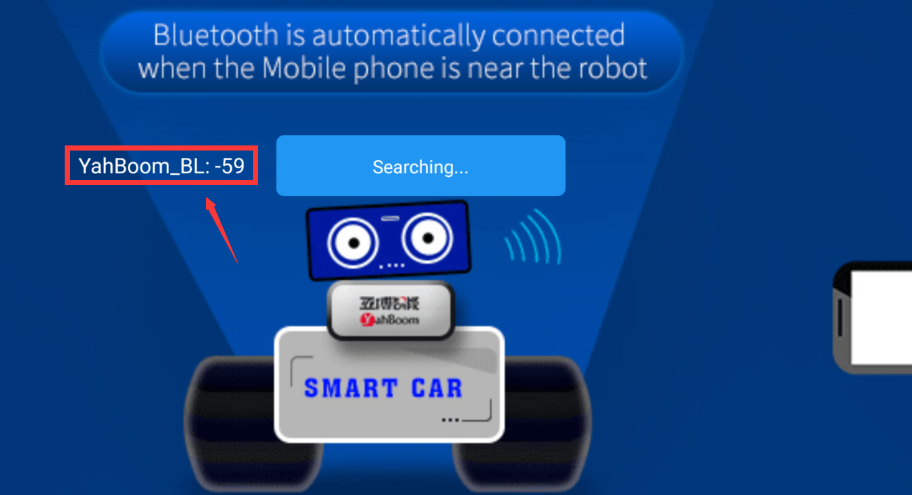

Step 11: Bluetooth can be successfully connected, and the APP will enter the interface as shown below. At the same time, the red indicator of the Bluetooth module will be keep on. You need to click”OK”.

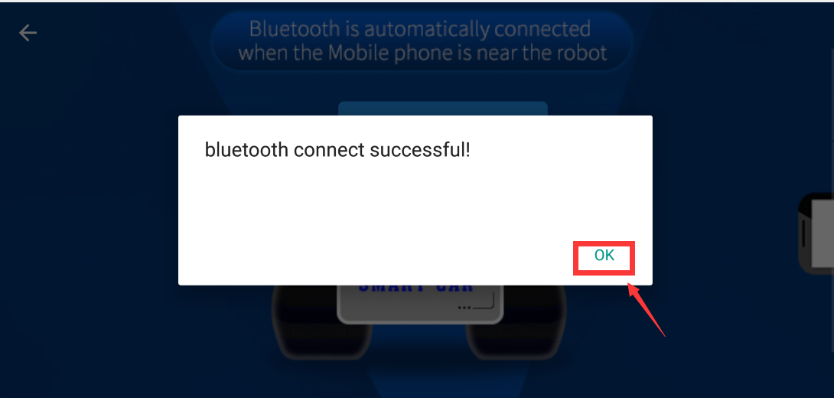

You will enter the interface as shown below.

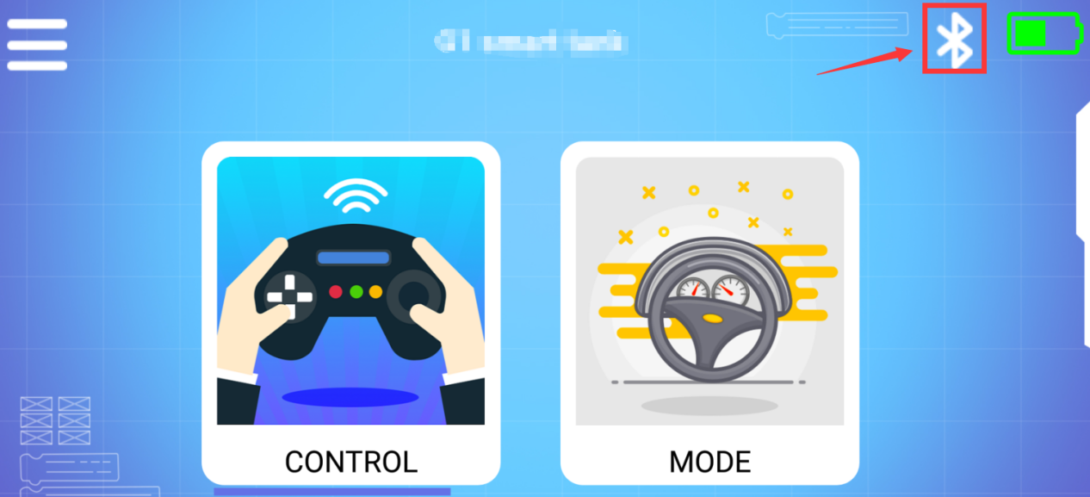

Step 12: Click “CONTROL” to enter interface as shown below. Wait for the ultrasonic data to change, it prove that Bluetooth starts to transmit data normally. You can start to control the car. You can start to control the Tank.

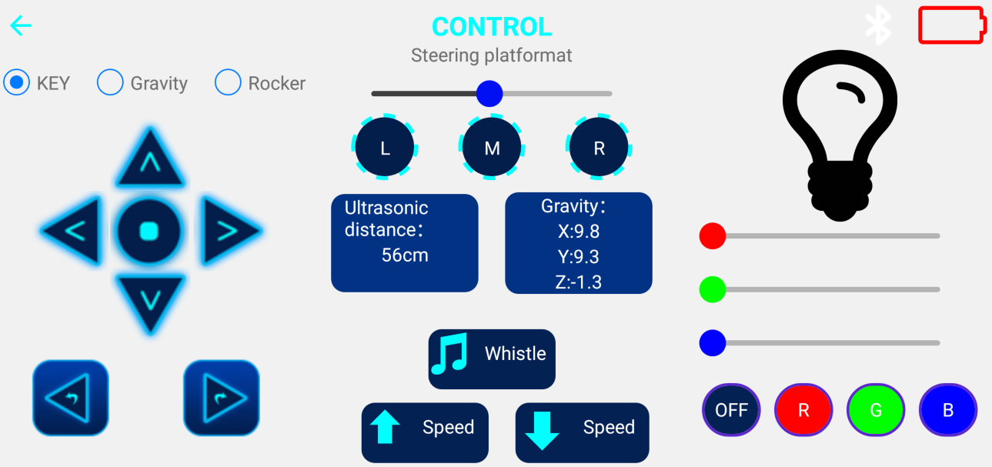

Step 13: Click “ MODE” to enter interface as shown below.

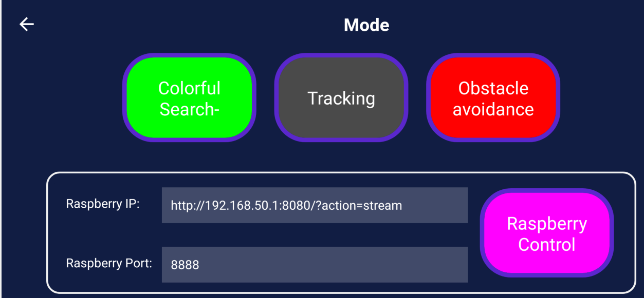

You need to pay attention to the points, otherwise the Bluetooth remote control function will have problems.

****Note:****

****(1)The robot Tank needs to have enough voltage to work properly. Please refer to the following figure for the charging method and battery usage:****

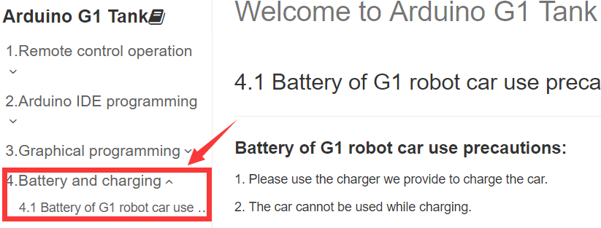

****(2)The Bluetooth module needs to be properly inserted into the expansion board of the Tank. As shown in the figure below.****

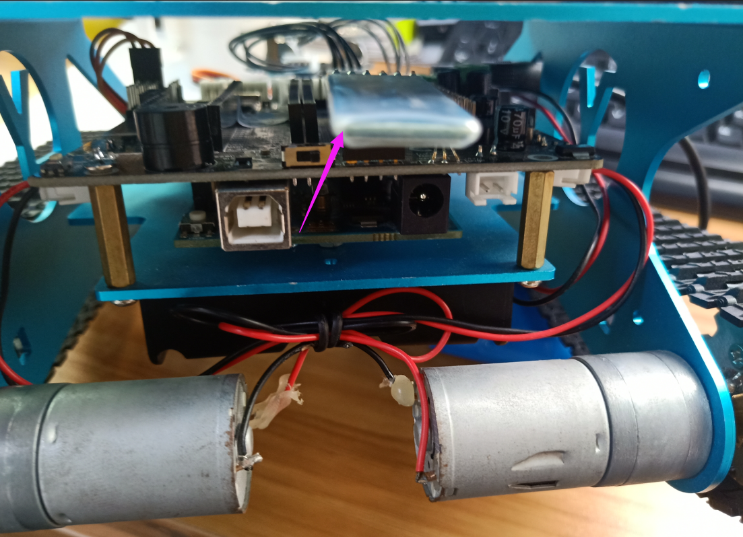

****(3) 51/Arduino Download Switch on the expansion board must be set to [OFF]. As shown in the figure below.****

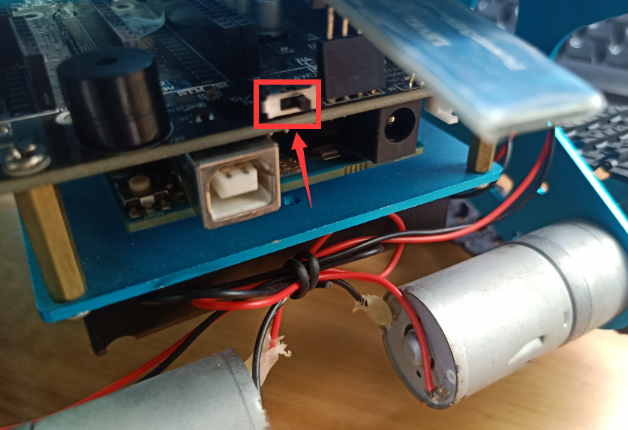

**(4)The ultrasonic module must be inserted. As shown in the figure below.**

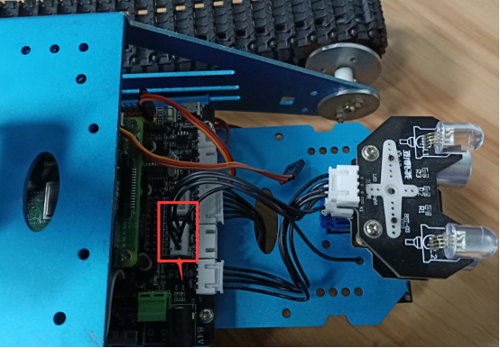

Please read our manual for introductions of Bluetooth remote control interface.

**About camera:**

If you want to use camera, you need to connect the camera and the Raspberry Pi motherboard correctly. The camera connection is as follows:

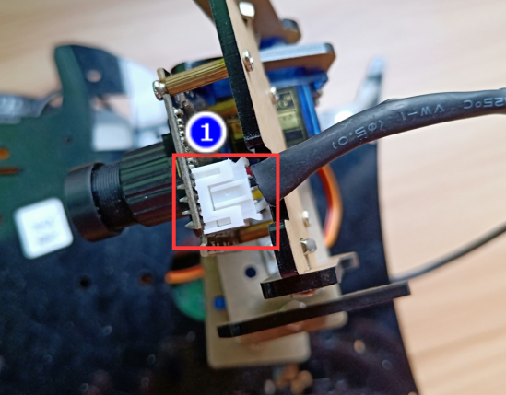

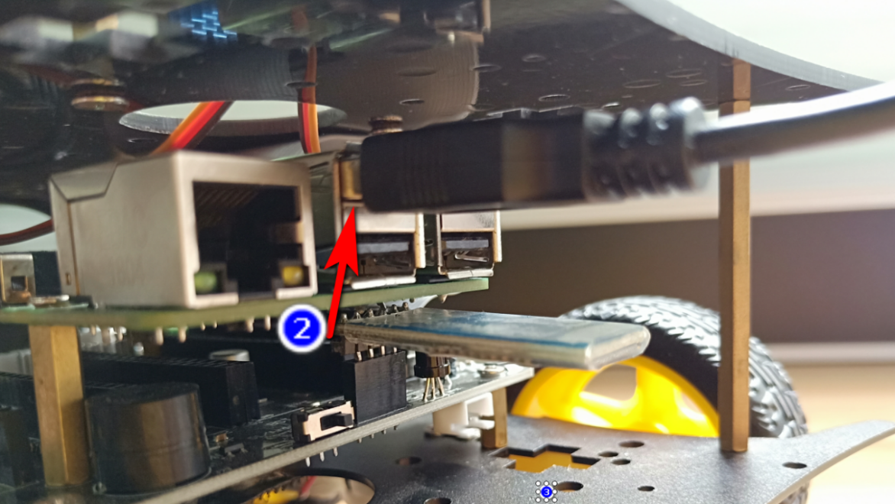

Your phone must connect WiFi of the Tank. Aa shown below.

**Name: Yahboom_Tank**

**Password: 12345678**

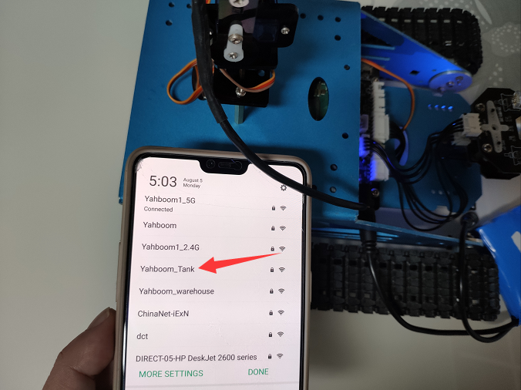

This WiFi is only used to transmit video and cannot be accessed online.

When you connect to WiFi, Click “**RaspberryControl**” you can see the picture taken by the camera on your mobile phone.

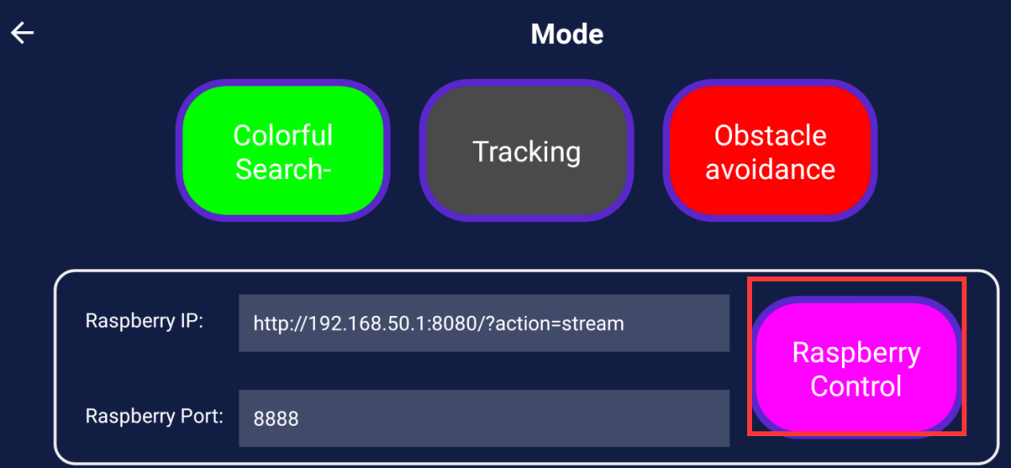

**IP address for 4B image:**

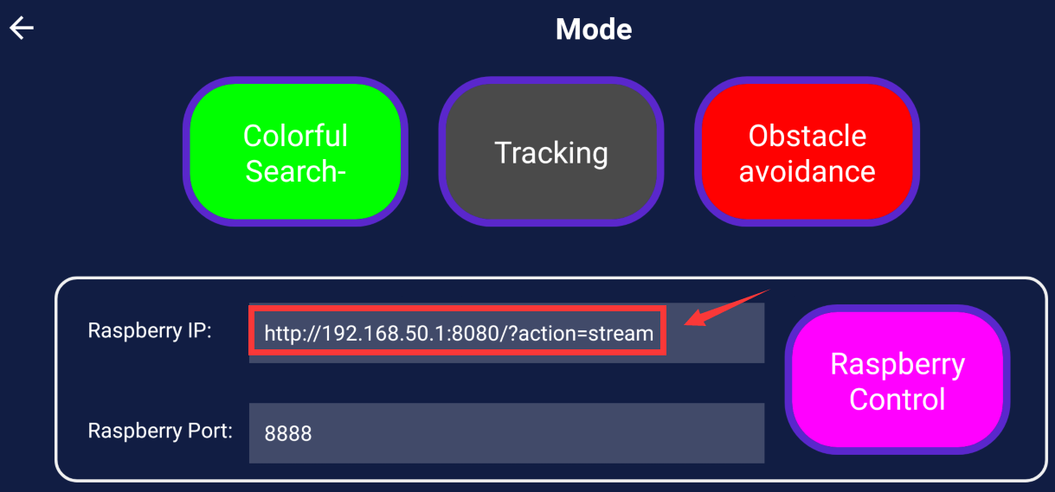

**IP address for 3B+ image:**

